create table logins(user_name varchar(25),mail_address varchar(20) ,user_pwd varchar(20), (mail_address),constraint pk_no primary key(mail_address));

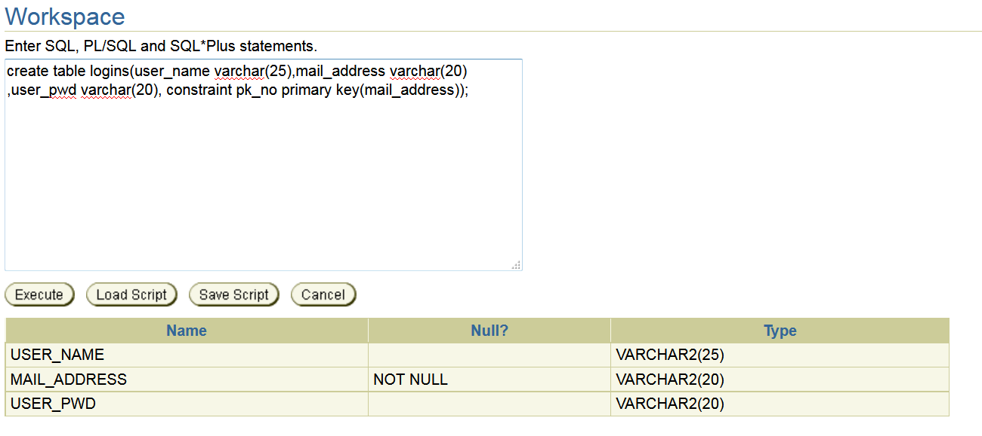

create table company_detail(c_referencID varchar(25),c_name varchar(20),c_location varchar(20),c_phone number,c_no_of_employees number,yearly_profit varchar(20),dealers varchar(20),c_contact number,constraint qk_s primary key(c_referencID));

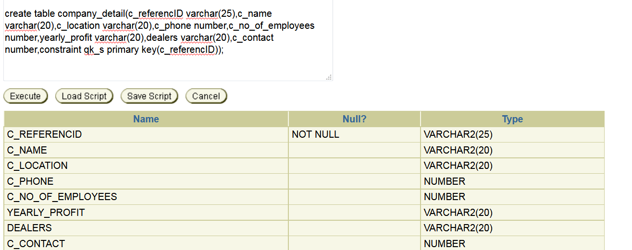

create table car_details(car_model varchar(20),car_brand_name varchar(20),car_c_refernceID varchar(25),car_body_type varchar(20),car_price number(10),car_engine_type varchar(20),
car_length number(10),car_weight number(10),car_fuelcapacity number(10),car_year date,monthly_EMI number(10));

create table employee(emp_code varchar(25),emp_name varchar(20),c_refernceID varchar(25),emp_DOB date,emp_contactno number(10),emp_dept varchar(25),emp_DOJ date,emp_salary number(10),emp_address varchar(25),emp_designation varchar(25),emp_loan_amount number(10),D_no varchar(20));

create table dept_details(D_no varchar(20),d_)name varchar(20),d_no_of_emp number(10),emp_code varchar(25),emp_designation number(10));

create table quality_control(product_name varchar2(20),test_no number(10),result varchar2(25),bug number(11),emp_code varchar(25),D_no varchar(20),constraint sk_d primary key(D_no),constraint fk_no reference quality_control(emp_code));

create table marketing(emp_code varchar(25),Date_of_launch date,price number(10),country varchar(15),type_of_ad number(10),D_no varchar(20),constraint ak_j primary key(D_no));
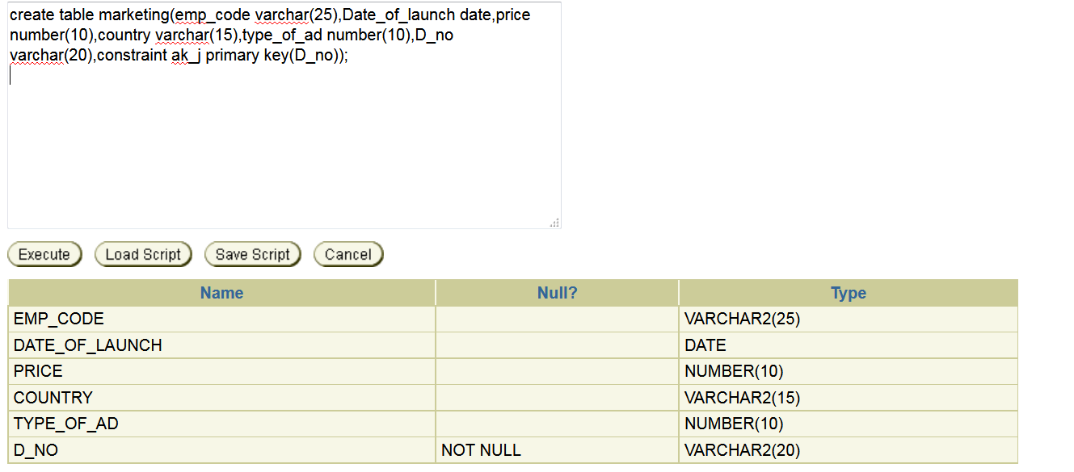

create table feedback(cus_name varchar(30),date_of_feedback date,address varchar(30),email varchar(20),comment varchar(20));

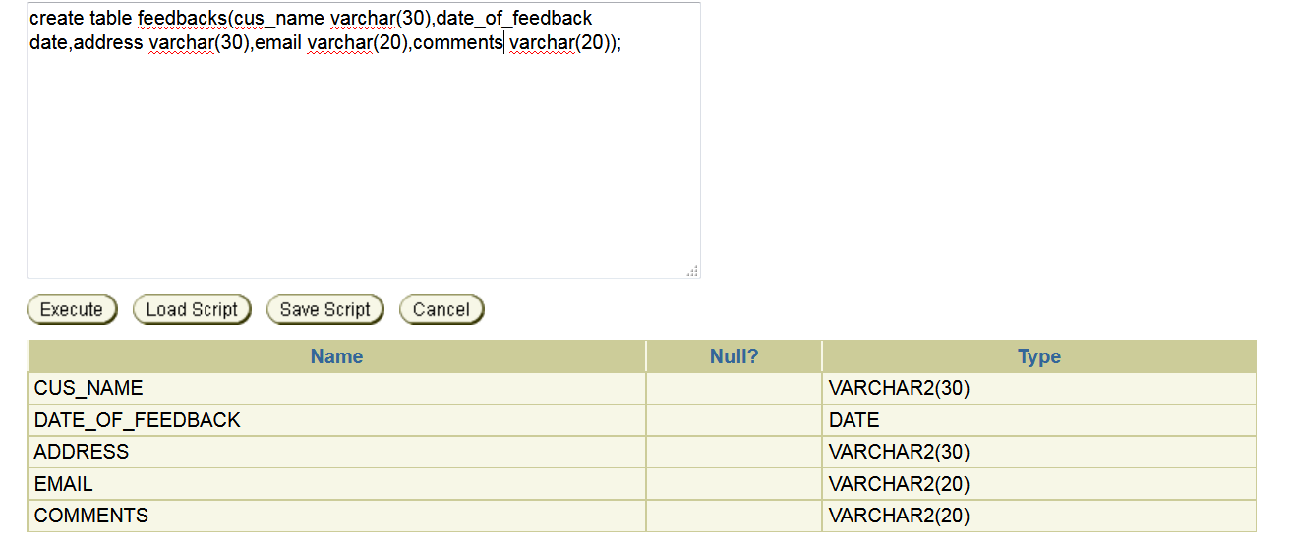

create table shippings(sh_no varchar(15),car_model varchar(15),price number(10),delivery_charge number(10),sh_address varchar(20),billing_address varchar(20));
